6A^{th} Grade: Unit 5, Lesson 8

- The double number line diagram represents the percentages of $10.00. What amount is 275% of $10.00?
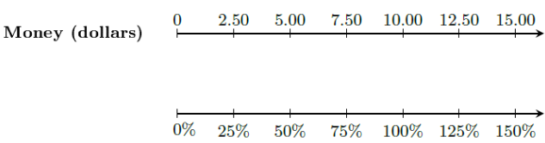
$27.50

- The double number line shown represents the amount of water a bucket can hold and the corresponding percentages. How much water will be in this bucket when it is 25% full?
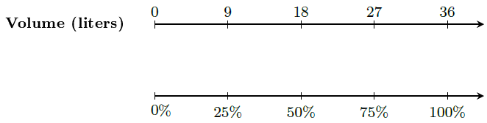

9 liters

- What percent of 80 is 20?
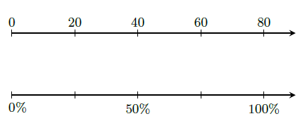

25%

